HeadShop 10 WIN

Artem - This may be the simplest job you ever had.

We will replace HeadShop plugin with the (latest build) Head 3D plugin.

1. Everything remains the same, except the splash screen:

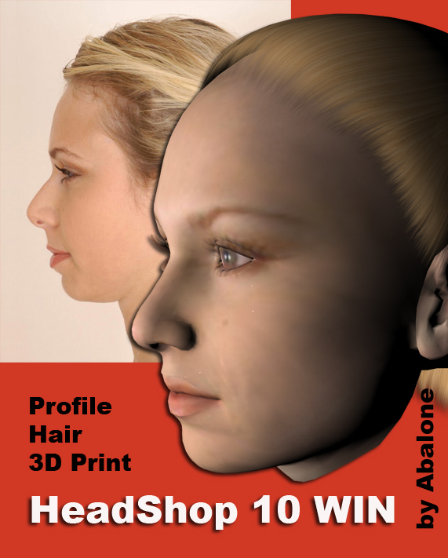

2, As per user requests add an options for higher resolution texture maps:

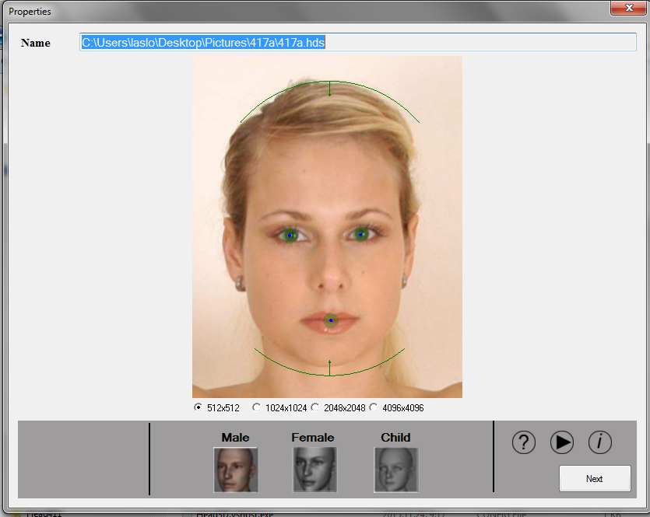

I propose $300 for the work (including clean-up and testing).